South Australia
Mile End Underpass Act 2005
An Act to provide for the construction of an underpass to replace the Bakewell Bridge at Mile End; to repeal the Mile End Overway Bridge Act 1925; and for other purposes.

Contents
1 Short title
2 Commencement
3 Interpretation
4 Commissioner may construct underpass and carry out other works
5 Minister may enter into agreement with owner of railway line
6 Designation of roads
7 Registrar-General to issue new titles in respect of certain affected land
8 Liability
9 Care, control and management of structures etc
10 Duties of Registrar-General and other persons
Schedule 1—Underpass construction area
Schedule 2—Repeal and transitional provision
1 Repeal of Mile End Overway Bridge Act 1925
2 Glover Avenue continues as public road
Legislative history

The Parliament of South Australia enacts as follows:
1—Short title
This Act may be cited as the Mile End Underpass Act 2005.
2—Commencement
This Act will come into operation on a day to be fixed by proclamation.
3—Interpretation
In this Act, unless the contrary intention appears—
Commissioner means the Commissioner of Highways;
roadwork has the same meaning as in the Highways Act 1926;
underpass construction area means the area identified as the underpass construction area in the plan in Schedule 1;
underpass project means the construction of an underpass to replace the Bakewell Bridge at Mile End and includes—
(a) earth works or demolition works undertaken for the purpose of that construction; and
(b) drainage or other infrastructure works undertaken for the purpose of that construction; and
(c) temporary works to divert pedestrians and traffic through, or around, the underpass construction area; and
(d) works to relocate or otherwise modify rail infrastructure in the underpass construction area; and
(e) roadwork undertaken in the underpass construction area and outside the underpass construction area in relation to Glover Avenue; and
(f) any other works undertaken in the underpass construction area in connection with the construction of the underpass.
4—Commissioner may construct underpass and carry out other works
(1) Despite any other Act or law, the Commissioner may, for the purpose of the underpass project, carry out—
(a) such works on land in the underpass construction area as the Commissioner thinks fit; and
(b) roadwork outside the underpass construction area in relation to Glover Avenue.
(2) The Commissioner may, for the purpose of carrying out the works authorised by this section—
(a) enter and remain on any land in the underpass construction area (with or without the consent of the owner of the land) and do any of the following:
(i) take any vehicles, machinery or equipment on the land;
(ii) make cuttings or excavations on the land;
(iii) deposit any material on the land;
(iv) undertake roadwork on the land;
(v) erect workshops, sheds and buildings of a temporary character on the land;
(vi) divert vehicles and pedestrians through any part of the land;
(vii) do any other works on the land necessary for the purpose of the underpass project; and
(b) temporarily close or limit the use of any railway lines in the underpass construction area; and
(c) temporarily close any road in the underpass construction area; and
(d) by notice in the Gazette, permanently close any road in the underpass construction area; and
(e) exercise any power of the Commissioner in relation to the carrying out of roadwork under the Highways Act 1926.
(3) The Commissioner must not carry out works within the area of the Adelaide Park Lands other than—
(a) temporary works for the purpose of the underpass project; or
(b) roadworks in relation to Glover Avenue (which must, on the completion of those roadworks, be no wider than it is immediately before the commencement of this section); or
(c) the construction of footpaths or bikeways (or both) within the underpass construction area.
(4) The Commissioner may, with the approval of the Minister, by notice published in the Gazette, assume the care, control and management of land in the underpass construction area for a specified period (which may be until further notice published in the Gazette).
(5) The Commissioner may, with the approval of the Minister, by notice published in the Gazette, vary or revoke a notice under subsection (4).
(6) This section is in addition to, and does not derogate from, any other powers of the Commissioner.
5—Minister may enter into agreement with owner of railway line
(1) The Minister may enter into an agreement with the owner of any land in the underpass construction area on which a railway line is situated relating to the exercise of powers by the Commissioner in relation to that land.
(2) An agreement entered into under this section may, for example—
(a) require that the Commissioner consult with the owner in relation to the exercise of powers on the land or the exercise of powers under section 4(2)(b) or make any other provision in relation to the exercise of those powers; or
(b) provide for the payment of compensation in circumstances specified in the agreement.
(3) The Commissioner must, in exercising the Commissioner's powers in the underpass construction area, comply with any requirements imposed on the Commissioner by an agreement entered into under this section.
6—Designation of roads
(1) The Minister may, by deposit of plans in the Lands Titles Registration Office designate as public road any land or structure within the underpass construction area.
(2) A public road designated under this section will be taken to have been established in accordance with the Roads (Opening and Closing) Act 1991.
7—Registrar-General to issue new titles in respect of certain affected land
(1) Where any land within the underpass construction area is held in fee simple by a person, the Minister may, after consultation with the person, by notice in writing to the Registrar-General require that—
(a) the fee simple to the land be cancelled; and
(b) the person be issued with a new title in respect of the land or in respect of any stratum of, or over, the land specified by the Minister and be granted any other interests or easements specified by the Minister.
(2) No stamp duty is payable in respect of any action taken under this section.
(3) The Land Acquisition Act 1969 does not apply in respect of any action taken under this section.
(4) This section applies notwithstanding the provisions of the Real Property Act 1886.
8—Liability
Subject to any agreement under section 5, the Crown, the Minister and the Commissioner do not incur any liability in respect of delays or disruptions to rail services arising from the exercise or purported exercise of powers under this Act or as a result of action taken under section 7.
9—Care, control and management of structures etc
(1) The Minister may, by instrument in writing, place any public road or structure constructed in the underpass construction area as part of the underpass project under the care, control and management of a person or body specified in the instrument subject to such conditions as the Minister specifies in the instrument.
(2) The Minister may, by instrument in writing—
(a) vary or revoke the conditions on which the road or structure was placed under the care, control and management of a person or body; or
(b) withdraw the road or structure from the care, control and management of that person or body,
and make such related or ancillary provisions as the Minister thinks fit.
(3) The Minister must cause notice of any instrument under subsection (1) or (2) to be published in the Gazette as soon as practicable after it is made.
(4) Any provision made by an instrument under this section will have effect according to its terms and despite any other provision of any other Act or law.
10—Duties of Registrar-General and other persons
If a plan is deposited in the Lands Titles Registration Office under this Act or notice of an instrument is published in the Gazette under this Act—
(a) the Registrar-General must amend, cancel or replace any document of title affected and make any entry in or amendment of the Register Book or the Register of Crown leases as required in consequence of the plan or instrument; and
(b) any other person required or authorised under an Act or law to record instruments or transactions relating to land must take any action necessary to give effect to the plan or instrument.

Schedule 1—Underpass construction area
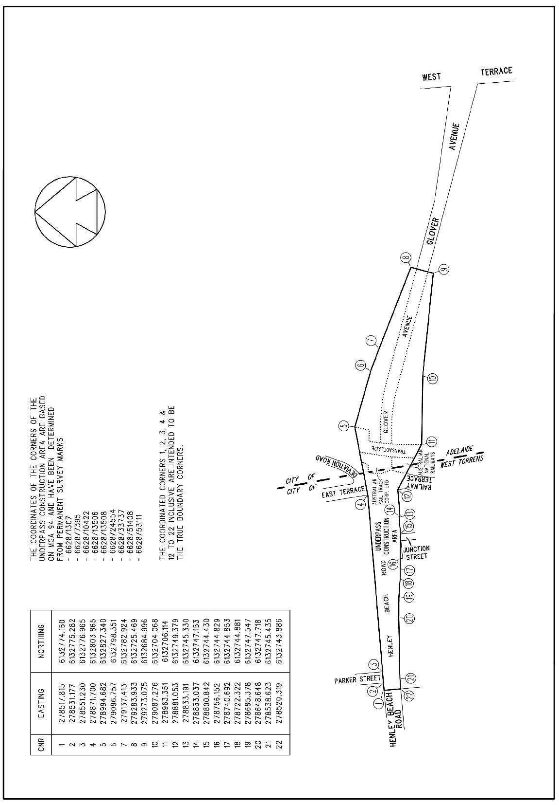

Schedule 2—Repeal and transitional provision
1—Repeal of Mile End Overway Bridge Act 1925
The Mile End Overway Bridge Act 1925 is repealed.
2—Glover Avenue continues as public road
For the avoidance of doubt—
(a) Glover Avenue continues as a public road despite the repeal of the Mile End Overway Bridge Act 1925; and
(b) the boundaries of Glover Avenue within the area of the Adelaide Park Lands are as delineated in the plan below:
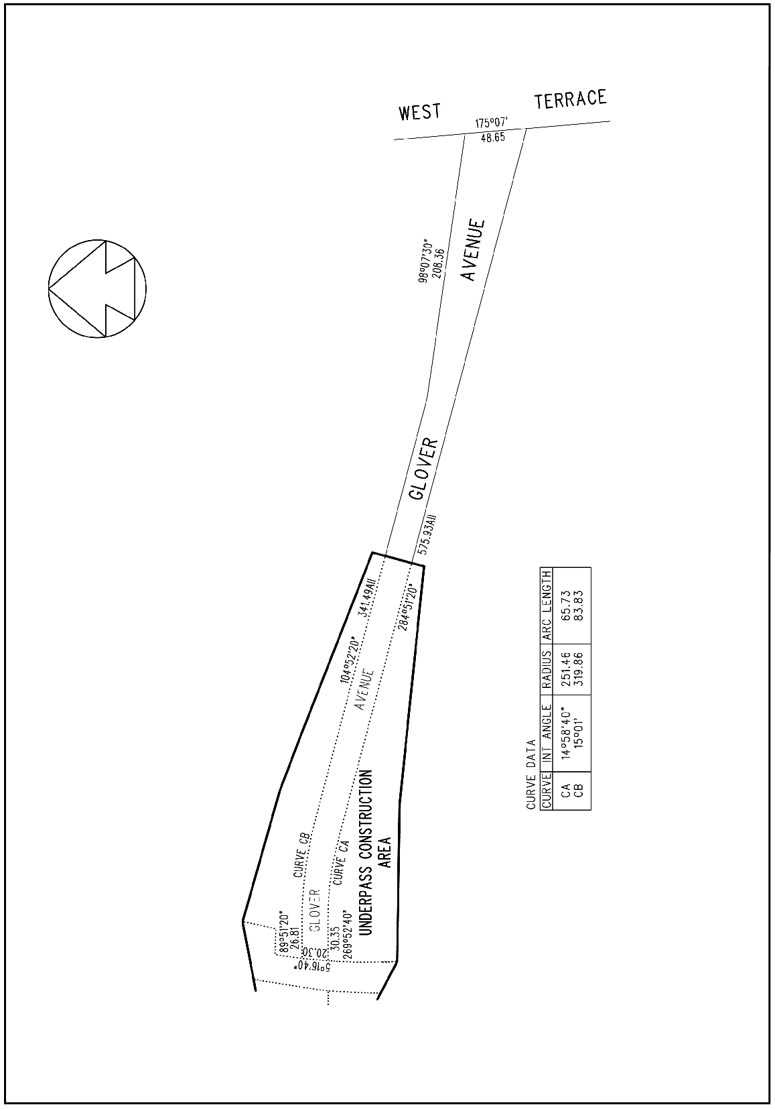

Legislative history
Notes
• For further information relating to the Act and subordinate legislation made under the Act see the Index of South Australian Statutes or www.legislation.sa.gov.au.
Principal Act
Year | No | Title | Assent | Commencement
2005 | 65 | Mile End Underpass Act 2005 | 1.12.2005 | 12.1.2006 (Gazette 12.1.2006 p44)

